Aspen Hills Thistle Eradication Plan

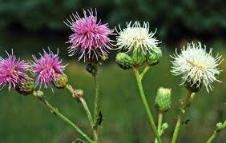

Problem:

Thistle (also known as Mountain Flower) has become a problem in recreational property developments throughout Utah. Utah has both the Bull Thistle and the Canadian Thistle. They look similar and are treated the same. Eradicating Thistle has been an ongoing effort in Willow Glenn for several years. Skyline Mountain Resort and Legacy Mountain started a concentrated effort a few years ago to eradicate Thistle from their subdivisions. Thistles are now a serious problem in Aspen Hills.

We need to begin a Thistle eradication program in Aspen Hills. It is a 3 -4 year process.

Step 1:
- Spray along all roads and common areas in Aspen Hills on designated work day
- For 2013 that day has been scheduled for June 29th
Step 2:
- Every property owner be responsible for spraying their own property
Step 3:
- Follow above steps for two to three more years, or until Thistle has been completely eradicated in all of Aspen Hills.
Thistle Spraying Instructions:
- Use 2,4-D Amine. Adding small amount of dish soap helps herbicide stick to plant
- A 4 gallon backpack sprayer is easier than a smaller 1 gallon hand sprayer
- Timely application is critical (Must be actively growing in the rosette stage)
- Spraying after flower blooms is not effective (Can cut off heads and burn them)

Thistle Facts:
- Germinate and grow into the rosette stage in the first year
- Over-winter in the rosette stage
- Bloom and produce seeds in the next growing season
- 80% of seeds are deposited within 55 yards of original plant
- Less than 1% blows more than 110 yards from the original plant
- Control through mowing difficult because of there are all stages of Thistles in population
- A single plant can produce up to 3,500 good quality seeds
- Seed viability is about 90% two months after they are produced
- Seeds may retain the ability to germinate for more than one year

